Terminator (Terminus)

📘 Definition
# Source: AI Source: Provided by: [Data Path: Persons Table -> ID Column: 1, Name_En Column: Motasem Essam] -> From: [ChatGPT] on [5/2/2026]
The Terminator (sometimes called Terminus) is the boundary line between the light side and the dark side of a 3D object.
It is where the surface changes from being lit by a light source to being in shadow.

🌗 How the terminator looks
# Source: AI Source: Provided by: [Data Path: Persons Table -> ID Column: 1, Name_En Column: Motasem Essam] -> From: [ChatGPT] on [5/2/2026]
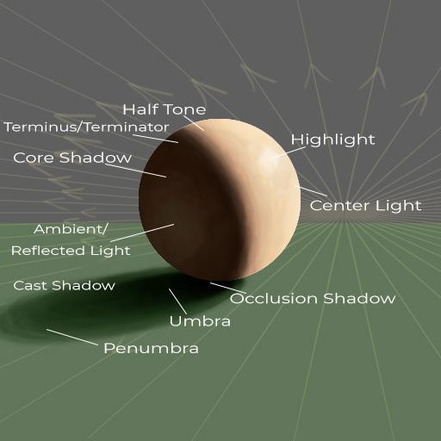
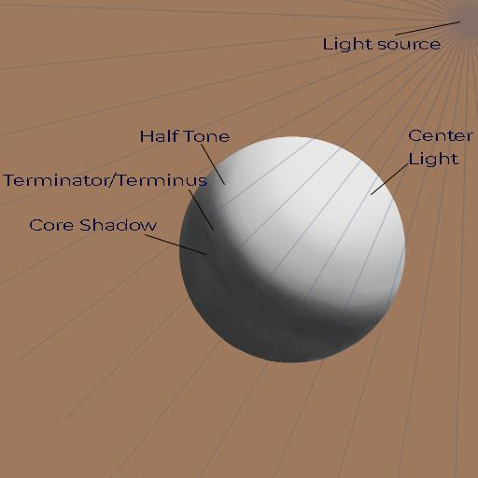
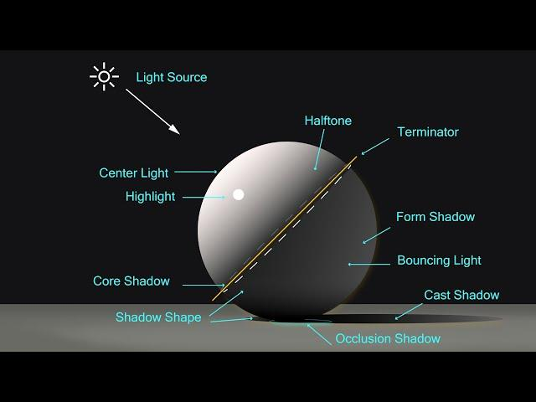
- One side = light (lit area)
- Other side = dark (shadow area)
- The dividing curve = terminator line

🧠 Simple example
# Source: AI Source: Provided by: [Data Path: Persons Table -> ID Column: 1, Name_En Column: Motasem Essam] -> From: [ChatGPT] on [5/2/2026]
Think of a ball under a lamp:
- ☀️ Front side → bright (light area)
- 🌑 Back side → dark (shadow area)
- 📍 The curved line between them → terminator

🎮 Why it is important in graphics
# Source: AI Source: Provided by: [Data Path: Persons Table -> ID Column: 1, Name_En Column: Motasem Essam] -> From: [ChatGPT] on [5/2/2026]
The terminator helps:
- Show the shape of 3D objects
- Create smooth light-to-shadow transitions
- Make objects look realistic and round

⚙️ Key features
# Source: AI Source: Provided by: [Data Path: Persons Table -> ID Column: 1, Name_En Column: Motasem Essam] -> From: [ChatGPT] on [5/2/2026]
- 📍 Separates light and shadow areas
- 🌗 Curved line on curved objects
- 🎯 Moves when light direction changes
- 🧩 Essential for realistic shading

🚀 In short:
# Source: AI Source: Provided by: [Data Path: Persons Table -> ID Column: 1, Name_En Column: Motasem Essam] -> From: [ChatGPT] on [5/2/2026]
Terminator (Terminus) = the line on a 3D object where light ends and shadow begins.

